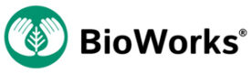

ROOTSHIELD® FALL REBATE PROMOTION
- Cost savings on RootShield and RootShield PLUS⁺ brands biological fungicide
- Strong, early protection of young plants against the ravages of root-infecting diseases
- Improve plant health, market quality and sell-through of your seasonal crops
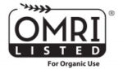
SUBMIT REBATE
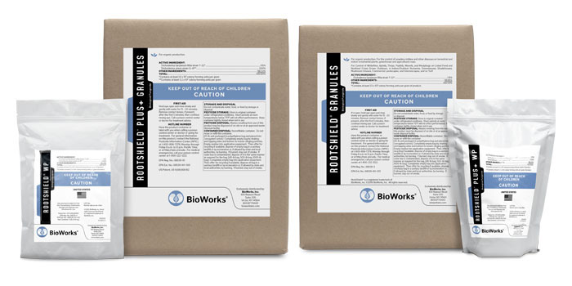
Don’t let the root infected diseases slow down the growth and delivery of your seasonal crops. RootShield and RootShield PLUS⁺ brand biofungicides have earned the trust to perform and protect valued crops of the industry’s leading commercial growing operations.

Step 1. Savings Rebates
Purchase any one of the qualifying RootShield brand biological fungicides from an authorized BioWorks® distributor beginning October 1st through December 31st, 2023 and you qualify for a Savings Rebate, as follows:
RootShield Branding | Unit Package | Minimum Purchase | Savings Rebate Per Unit | Savings Rebate Earned
RootShield WP and RootShield PLUS+ WP | 3 lbs | 36 lbs (12 units) | $5.00 / lb | $180.00
 | 30 lbs | 60 lbs (2 units) | $5.00 / lb | $300.00
RootShield G and RootShield PLUS+ G | 40 lbs | 400 lbs (10 units) | $0.50 / lb | $200.00
 | 500 lbs | 1000 lbs (2 units) | $0.50 / lb | $500.00
 | 1000 lbs | 1000 lbs (1 unit) | $0.50 / lb | $500.00
Our goal is to ensure you experience the most efficient and economical applications of RootShield brand fungicide in addition to any BioWorks branded products used in your commercial growing system. Gain confidence and overcome challenges from the practical guidance offered by the experts at BioWorks. Above and beyond is where we begin to help you grow the value of your brand.
Always Read and Follow Label Use Directions
Program Specifics
BioWorks Qualifying Products and Bonus Products:
RootShield WP, RootShield PLUS⁺ WP brands, RootShield G, RootShield PLUS⁺ G brands
Program Period  October 1 – December 31, 2023 | Rebate Form(s) Submission Period  October 2, 2023 – July 15, 2024
Take Delivery Period  October 2, 2023 – June 15, 2024 | Rebate(s) Payment Delivery Date  On or before September 30, 2024

Promotion Rebate Submission
Please fill out the form below to submit your rebate. The Program is limited to sales and purchases of the Qualifying Products to within the U.S.A. (For additional details please Refer Here). All forms must be submitted by July 15, 2024 to qualify.
"*" indicates required fields

Company Name*
Your Name*
Email*
Phone*
Address*
Street AddressCity
AlabamaAlaskaAmerican SamoaArizonaArkansasCaliforniaColoradoConnecticutDelawareDistrict of ColumbiaFloridaGeorgiaGuamHawaiiIdahoIllinoisIndianaIowaKansasKentuckyLouisianaMaineMarylandMassachusettsMichiganMinnesotaMississippiMissouriMontanaNebraskaNevadaNew HampshireNew JerseyNew MexicoNew YorkNorth CarolinaNorth DakotaNorthern Mariana IslandsOhioOklahomaOregonPennsylvaniaPuerto RicoRhode IslandSouth CarolinaSouth DakotaTennesseeTexasUtahU.S. Virgin IslandsVermontVirginiaWashingtonWest VirginiaWisconsinWyomingArmed Forces AmericasArmed Forces EuropeArmed Forces Pacific

StateZIP Code
Purchase Receipt Files*
Drop files here orSELECT FILES
Accepted file types: jpg, gif, png, pdf, Max. file size: 50 MB, Max. files: 6.
CAPTCHA

RootShield Fall Rebate Promotion
End-User Rebate Processing and Payments
Using a desktop or laptop computer, tablet, or mobile phone, end-user Purchaser may simply follow directions at bioworksinc.com/rootshield-fall-eop, or use the QR code below. Following delivery and receipt of the product(s) during the Take Delivery Period, the purchaser must complete the online Rebate Request Form, attach the required digital copy, image, or photo of the product purchase PO(s) or purchase receipt(s), and submit electronically to BioWorks Inc. as instructed at the online webpage.
Submitted Rebate Request Forms and required documentation will be validated by BioWorks Inc prior to rebate payment. All Rebate Request Forms must be submitted complete no later than July 15, 2024 to be eligible for the promotion rebates and payment.
Rebate payments will be processed, made payable-to, and delivered directly to the end-user Purchaser at the location specified in the Rebate Request Form no later than September 30, 2024.
Multiple RootShield brand order receipts may also be consolidated and submitted under one Rebate Request Form for processing as a single rebate payment by the end-user Purchaser. Similarly, this submission will be made payable-to and delivered to the location indicated on the Rebate Request Form.
Conditions, Limitations, Restrictions
Once the minimum purchases of RootShield brand are met, additional qualifying orders may be placed within the Program Period and will qualify for the Savings Rebates.
Additional Rebate Forms must be submitted for each additional order placed for qualifying RootShield brand products purchased during the Program Period. Proof of purchase receipt or approved documentation must accompany the Rebate Request Form in order to process and determine the Program Rebate(s) payment.
No exceptions.
No maximum purchase limitations.
The Program is limited to sales and purchases of the RootShield brands within the U.S.A., its states and territories, and to where the RootShield brands are approved and lawfully registered to be sold.
Sub-distributors and resale dealers do not qualify for the Program Rebate(s).
The determination of the end-user Program Rebate(s) payment is restricted to the stated RootShield brands purchased during the Program Period. No other BioWorks products, programs, or promotions may be included in the qualification for and determination of the end-user Program Rebate(s) payment.
BioWorks reserves the right to terminate the Program at any time.
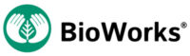
BioWorks®
100 Rawson Road
Suite 205
Victor, NY 14564
Phone: (800) 877-9443
customerservice@bioworksinc.com
Copyright 2023 BioWorks®, Inc. | All Rights Reserved

